The Usability of a Radial menu structure Versus Inline menu structures for use by novice users

Neil Eastwood,

BSc (Hons) <Computing>

Project: Database driven web site which incorporates a bespoke Content Management System, Action Script 3 gallery and Flash Based web Game.

Supervisor:

Second Reader: Cheryl Grabarz

23 November 11

**Abstract**

Novice users can be difficult to please as they are unsure of what they actually want out of a system or design, designing for the novice can be a particular challenge for a developer as what they believe is a perfectly usable menu design may be seen as the opposite by a novice user. This paper examines the advantages and disadvantages of the radial and linear designs for menus and discusses expanding on these designs. Other factors which need to be considered when designing a menu for the novice are also covered.

## Introduction

### Context

A menu’s design plays a significant role in a user’s satisfaction of a software package or system; therefore, research has been carried out on various elements which make up a menu’s layout and structure (Kim et el 2011).

Despite this, menu design is often underestimated or overlooked by developers in both web design and application development.

Users, especially novices, can quickly become disheartened or frustrated when they are prevented from being able to easily interact with a system due to the menu which is too complex or overly sensitive, (Poteet 2010).

Radial and linear menu architectures both have benefits and draw backs which should be considered when designing any new system. By having a better understanding of menu architecture, a richer interface can be created which still maintains a high level of usability (Callahan et el 1993a).

### Overview

The body of this paper has been broken down into four sections, which are as explained below :-

Section 2 details the fundamental differences between radial menus (also known as pie menus) and linear menus. Illustrations of both are given to help the reader form a better idea of the topics discussed within this paper.

Section 3 and 4 discuss the potential benefits and drawbacks of using a Radial based menu system (section 3) and Linear based menu system (section 4). The usability theory behind the menu designs are also discussed and benefits of the different designs on different devices.

The conclusion argues which menu if any is better for the novice user.

## What is the basic difference between the two menus

Before we can discuss the potential benefits or draw backs of a particular menu design, and the effects they have on a novice user, one must first understand the basic fundamental differences between the two menu architectures.

A radial menu (see appendix 1), which is also referred to as a pie menu, is a format where each element is positioned around the circumference of a circle; each element held within the menu is placed at an equal radial distance from the centre of the menu structure (Lammi 2010).

This design is based on Fitts’s Law (1954) which describes the time to move to a particular target, the distance from the starting point to the target and the size of the target. This theory, when applied to menu design, results in the circular shaped menu system which is cut into sections; hence the name pie menu. This theory is discussed later within the document for now it is enough to just know the basic idea behind the Radial designed menu.

A linear based menu design (see appendix 2) is a far more traditional layout with elements of the menu being placed either horizontally or vertically along the menu. This method is widely used within web site design and a wide range of software packages on multiple platforms. However just because it is a format regularly used; is it a clear indication that the linear design is the right menu design to use regardless, of users level of experience or skill?

## Advantages and Disadvantages of Radial Menus

A menu based on the Radial design has several benefits when compared to that of other menu designs. These benefits are widely due to Fitts (1954) law, which is an equation that has been incorporated into the radial design. This equation calculates the Time to reach the desired target from the centre of the menu structure, and then measures the distance travelled and size of the desired target. A clear pattern arises when this equation is followed and times are compared and recorded compared to the Linear design.

Fitts’s work has been taken a step further by Callahan et al (1993b). Their research examined Fitts’ s law and the correlation between it and the number of errors which occur when using the two menu types. This research identifies several of the benefits of using a radial menu design. Using the radial design reduced seek times (meaning the time taken to locate, target and move to the desired element within the menu.) and also reduced the number of errors which occurred overall across all the participants within the trail (see appendix 3). A similar article written more recently by Samp and Decker (2010) also supported the idea that the design of the radial menu increases usability by reducing seek times and errors while using the menu.

Callahan et al (1993c) do go on to say that there are issues when using pie menus due to the amount of space they require on the display and the limitations of them in regards to the number of elements which can be placed into a single radial design. These disadvantages have also been highlighted by Rubio and Janecek (2002, p 39 ) who state :-

“Pie menus have several disadvantages. They use a large amount of screen space, and the number of elements in a single menu is limited to eight.”

Since Wiseman et al (1969) first came up with the radial design there has been a number of more advanced radial based designs, such as the Wave design which tries to overcome the disadvantages just discussed. Bailly et al (2007) explain that the way the design accomplishes this is by allowing for multiple sub menus to appear by expanding the menu circumference and creating a smaller radial menu within the original menu (see appendix 4).

This overcomes the issue of the limited number of elements which can be placed within the menu while maintaining the benefits a novice user may gain from using the radial design. However the issue of the amount of screen space the menu will take up is exacerbated and could lead to the menu blocking the users view to a particular area of the system or package the menu has been implemented into.

One way of removing the disadvantage of the screen space amount the radial design takes up is to turn the menu into a pop up. Doing so allows a maximum use of screen space with no area being constantly reserved for the menu as it only appears as and when needed. However this approach may be fine for more experienced users, but has negative effects on novice users as it increases the cognitive load resulting in higher levels of stress and learning times for the novice user (Baecker et al, 1995, p 194)

Both the radial design and more advanced off shoots of the design have been far more embraced within the games development industry compared to other industries. This is widely due to the high level of usability and accessibility the design brings. As stated by Miles (2011) :-

“In a game, people want the content delivered to them in a way that doesn’t break the fantasy. Any dissonance with the interface will cause an otherwise great game to fail.”

She goes on to point out that the radial design can play a big part in accomplishing this goal when designers approach the games interface layout Miles(2011).

The reasons for the radial menu being so popular within the games industry is widely down to the method of input that has been broadly used for consoles over the last several decades, these being the directional pad and more recently the analogue stick. They blend very well with the radial design allowing even novice users to quickly learn to interact with the games interface very easily. This fact has played a large part in the adoption of the radial design within this industry (Chertoff et al 2009, p 2).

The touch screen input method used on smart phones and tablets also blends well with the radial menu design. An example of this is the iPhone which has embraced radial design over that of more traditional formats. This alone should immediately highlight the radial designs high level usability and learn ability, as the iPhone is considered to be one of the easiest to use and most functional phones currently on the market (Chris Adams 2011). This is down, in no small part, to the interface methods e.g. radial menus, and the ability of inexperienced users to be able to pick up and use the phone.

There are no guarantees that the radial design will perform as well when input methods besides the ones just discussed are employed into a system. Because of this, both users of the system or package and the platform the interface is going to be used on should always be carefully assessed (Sears and Jack 2008). Meaning the radial design may not automatically be the better choice of menu design despite the well documented benefits they hold, especially for novice users.

**4 Advantages and Disadvantages of Linear Menus**

Linear based menus are the most commonly seen design format for menus in both software development and web design (Jenkins 2009, p 146). Despite experts in the field of HCI (Human Computer Interaction) such as K. Norman publishing books and papers pointing out the advantages other designs have over the linear design.

The linear design is not all bad, however, as it does have advantages in specific areas over that of other menu types. Campos et al (2011, p 251) point out that the linear menu’s ability to allow users to pre-visualize what sub menus are going to be available is often over looked or underestimated. Users are also able to quickly scan the elements held within the submenus by simply positioning the mouse (or whichever input method they have available to them) over the initial categories; this helps reduce the learning times of more complex systems which require large menu structures to function, this advantage can benefit both novice and experienced users. Though the findings of Norman (1991, p 27) suggest that novice users find these extended linear designs awkward to use and confusing to control movement through.

The other strengths of the linear design lie in the polar opposites to that of the radial design. Linear menus don’t demand a large area of screen space nor do they have a limit on the number of elements which can be placed within them. This is unlike radial designed menus which can only fit up to 8 elements into the structure before usability is scarified for functionality (Helander et al, 2007, p 545).

One of the main needs which should be considered when designing any interface for a novice user is simplicity. Keeping the interface and control techniques simple will help ensure the user will not become confused or frustrated and stop using the system. An example of this is to give the initial menu structure the user would see between two and four options to choose from, doing so keeps the interface simple but still allows for a reasonable amount of functionality to be included. When this is considered and research undertaken by the likes of Kurtenbach (2004) is examined the linear design becomes a much more appealing option to use when creating an interface for a novice user.

The performance difference between the radial and linear designs only becomes apparent when the number of elements within the menu is five or greater. When the number of elements held within the menu is between one and four the difference in seek time and accuracy is not very significant in some cases the linear menu marginally beats the radial design on seek time (see figure 1). This idea is supported by Kurtenbach (1993a, p 81) who also suggests within his findings that the target accuracy showed no significant differences between radial and linear designs until the number of elements held within the menu was increased to five plus. Callahan et al (1993d, p 69) also support this idea.

**Figure 1**

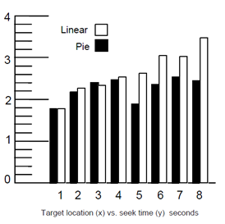

It should be noted however that figure 1 and appendix 3 both show a significant increase in seek time and decrease in target accuracy when the number of elements within the design is increased. This puts the linear design at a significant disadvantage and also indicates the design would cause problems for novice users if the required number of elements included needed to be five or more Kurtenbach (1993b).

## 5 Conclusion

When designing specifically for a novice user, the type of menu design is an important element to the system or package being created. Both designs discussed have benefits which will aid both the user, and the overall usability and functionality of the development.

However other factors such as the platform the user will be operating, as well as the method of input being using, all impact the usability (Kortum, 2008).

If the interface only requires between 2 to 4 elements to be held within the menu structure and screen space is an issue, the linear design seems to be the more attractive design as it will enable the novice user to operate the menu with relative ease while conserving screen space. If more than 4 elements are required the radial design is the clear choice as it will reduce the novice’s cognitive load and improve his or her seek time and target accuracy.

Other factors should also be considered such as whether the menu needs to be dynamic (the elements within the menu structure can fluidly change) or static (elements within the structure do not change) before a particular design is chosen. These factors can be crucial to the overall success of the design. Mitchell and Shneiderman (1989) found in studies carried out that :-

“When comparing dynamic versus static menus, using a menu-driven computer program, it was found that for the first set of tasks adaptive dynamic menus were significantly

slower than static menus. Moreover, 81% of the subjects preferred working

with static menus to working with dynamic menus. This preference is likely

because dynamic menus can slow down first time (novice) users”

This added factor, along with the others discussed, indicates that when designing for novice users external factors which would not immediately come to mind need to be carefully thought about. Expansions to the initial design chosen should also be carefully accessed in order to overcome some of the disadvantages the chosen design has. An example of this would be to expand on the radial design to create the wave design, which has both a starting novice state and allows for a smooth transfer to more advanced or expert states. Making these considerations can enable the user to make the transition from novice user to experienced user with relative ease (Bailly et al, 2007).

**Appendix 1**

Example of a radial menu taken from a audio player on Ubutnu which was themed on iTunes.

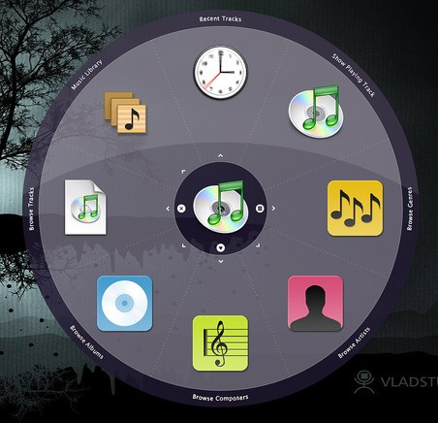

**Appendix 4**

Linear designed menus taken from Google.

Horizontal linear design



Vertical linear design



**Appendix 3**

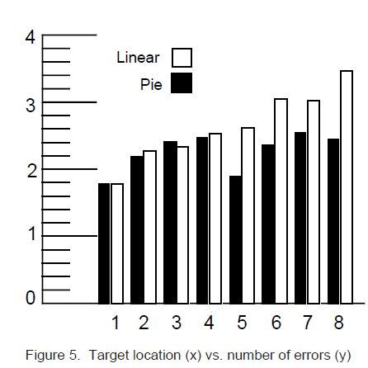

This graph displays the target location plotted against the total number of errors across all the subjects involved within the trail.

(Callahan et al, 2011, p 70)

**Appendix 4**

**Wave Menus**. (State A) The menu appears centred around the cursor. By drawing a

stroke towards a desired item (Transition 1), the first level menu is enlarged to leave room for

the submenu (State B).

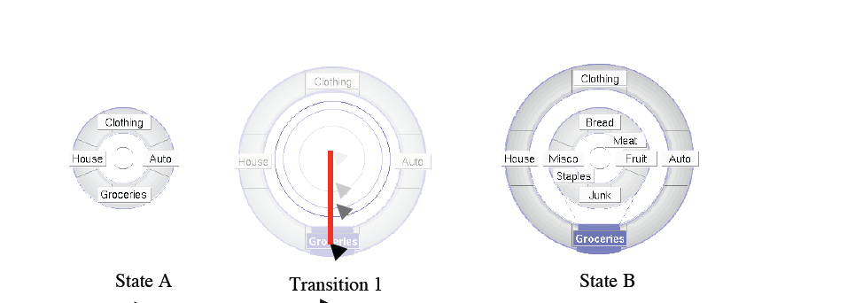

(bailley et al, 2007, p 2)

## 6 References

## Adams .C (2011): An Ergonomic Review of the iPhone by Apple

<http://ergonomics.about.com/od/buyingguide/fr/iphone.htm> (accessed 14/11/2011)

Bailly .G, Lecolinet .E & Nigay .L (2007a): Wave menus: Improving the Novice Mode of Hierarchical Marking Menus, Vol 4662/2007, pp- 475-488

Bailly .G, Lecolinet .E & Nigay .L (2007b): Wave menus: Improving the Novice Mode of Hierarchical Marking Menus, Vol 4662/2007, pp- 2

Baecker .R M, Grudin .J, Buxton .W & Greenberg .S (1996): Readings in Human-Computer Interaction: Toward the Year 2000, 2nd Revised edition, San Francisco:Morgan Kaufmann

Callahan .J, Hopkins .D, Weiser .M & Shneiderman .B (1993a): An empirical comparison of pie vs. Linear menus, Sparks of Innovation in Human-Computer Interaction, Vol 2.2, pp- 64 – 67

Callahan .J, Hopkins .D, Weiser .M & Shneiderman .B (1993b): An empirical comparison of pie vs. Linear menus, Sparks of Innovation in Human-Computer Interaction, Vol 2.2, pp- 68 – 70

Callahan, Hopkins, Weiser and shneiderman (1993c): An empirical comparison of pie vs. Linear menus, Sparks of Innovation in Human-Computer Interaction, Vol 2.2, pp- 95- 100

Callahan .J, Hopkins .D, Weiser .M & Shneiderman .B (1993d): An empirical comparison of pie vs. Linear menus, Sparks of Innovation in Human-Computer Interaction, Vol 2.2, pp- 69

Campos .P, Graham .N, Jorge .J, Nunes .N (2011):Human – computer Interaction - INTERACT 2011 :13th IFIP TC 13 International Conference, Lisbon, Portugal, September 5-9 2011, Proceedings, Part II

Chertoff .D, Byers .R & LaViola .J(2009): An Exploration of Menu Techniques using a 3D Game Input Device, Vol , pp-2

Fitts ,P.M. (1954): The information capacity of the human motor system in controlling the amplitude of movement. Journal of Experimental Psychology, Vol 47, pp- 381-391.

Helander .M, Landauer .T K & Prabhu .P (1997): Handbook of Human-Computer Interaction, end Revised edition, New York: Elsevier Science Ltd

Jenkins .S(2009): Web Design All-in-one For Dummies, Indiana: Wiley publishing. Inc

Kim .K, Jacko .J & Salvendy .G (2011): Menu Design for Computers and Cell

Phones: Review and Reappraisal, International Journal of Human-Computer Interaction, Vol 27:4, pp- 383-404

Kortum (2008): HCI Beyond the GUI: Design for Haptic, Speech, OIfactory and Other Nontraditional Interfaces (Interactive Technologies), New York :Morgan Kaufmann

Kurtenbach .G(1993a): The Design and Evaluation of Marking Menus, Vol 1, pp- 81

Kurtenbach .G(1993b): The Design and Evaluation of Marking Menus, Vol 1, pp- 77-88

Kurtenbach .G (2004): Notes on the History of Radial menus, Pie menus and Marking menus

<http://web.archive.org/web/20070824083657/http://www.dgp.toronto.edu/~gordo/papers/Notes+on+History+of+Radial+Menus.pdf> (accessed 21/11/2011)

Lammi .J (2010): Radial Menu

<http://patternry.com/p=radial-menu> (accessed 19/11/2011)

Miles .A (2011): What Web Designers can earn from Video Games

<http://www.smashingmagazine.com/2011/07/27/what-web-designers-can-learn-from-video-games> (accessed 21/11/2011)

Mitchell, J., & Shneiderman, B. (1989). Dynamic versus static menus: an exploratory

comparison. *ACM SIGCHI Bulletin*, *20*(4), 33–37

Norman .K(1991): The Psychology of Menu Selection: Designing Cognitive Control at the Human/Computer Interface

# Poteet .C (2010) [Making DHTML Menus Suck Less](http://www.siolon.com/blog/making-dhtml-menus-suck-less/)

<http://www.siolon.com/blog/making-dhtml-menus-suck-less> (accessed 18/11/2011)

Rubio .J .M & Janecek .P (2002): Floating Pie Menus Enchancing the functionality of the Contextual Tolls, Vol 2, pp- 39

Samp .K & Decker .S (2010): Supporting menu design with radial layouts, In Proceedings of AVI'2010, pp- 155~162

Sears .A & Jacko .J (2008): The Human Computer Interaction Handbook: Fundamentals, Evolving Technologies and Emerging Applications, Second Edition, pp- 332-535